Thymus vulgaris
Thyme // Timo
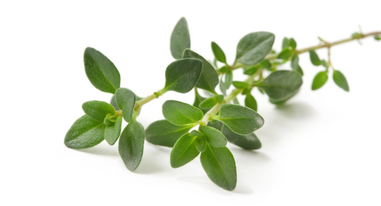

Description
Thyme is a delicate herb with a strong fragrance.

In food
Thyme can be added to pasta dishes/sauces for flavour. It can also be added to bean, egg and vegetable dishes; fresh thyme adds a fragrance to omelettes and scrambled eggs. You can also add thyme to fish or use to season soup.

Health Benefits
Thyme can be added to other ingredients to create an oil called Thymol that is used for healing purposes.

Thyme can be used for chest and respiratory problems including coughs, bronchitis, and chest congestion. Thymol can also be used to increase the amount of healthy fats in cell membranes, particularly in the heart, kidney and brain.

In the past
Ancient Egyptians used Thyme to keep the mummified bodies fresh. Thyme was also a commonly used healing herb in WW1.

